Problem 1: Insertion Sort (Ascending Order)

Objective
- To implement the Insertion Sort algorithm using C++.
- To take user input for the number of elements and array values.
- To sort the given list of numbers in ascending order.
- To understand how elements are inserted into their correct position step by step.
- To observe the working principle of a simple comparison-based sorting technique.

Source Code
Input and Output
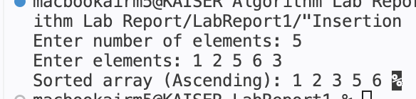
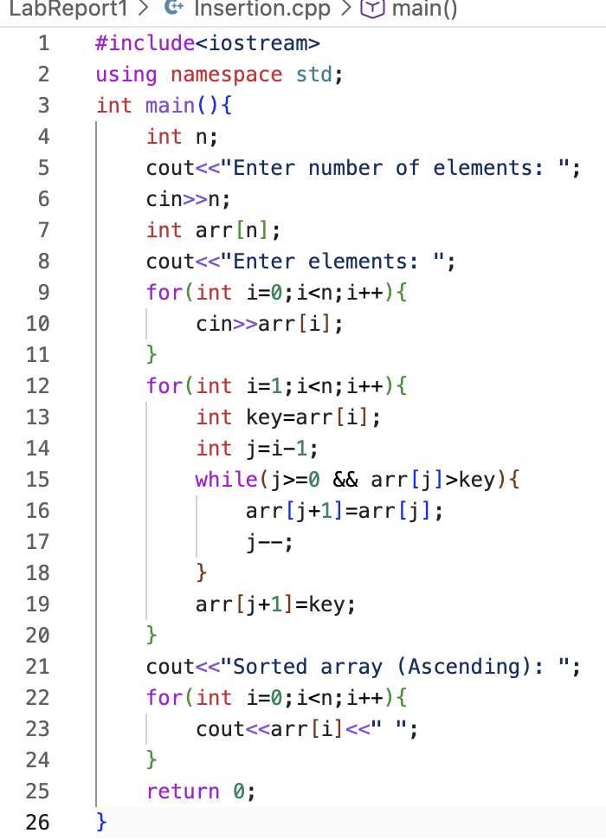

Conclusion
The given program has been successfully implemented using the Insertion Sort algorithm. The input elements have been arranged in ascending order by inserting each element into its correct position. The sorting process has been executed step by step, and the final sorted array has been obtained correctly. It is concluded that Insertion Sort works efficiently for small datasets.

Problem 2: Bubble Sort (Descending Order)

Objective
- To implement the Bubble Sort algorithm using C++.
- To take user input for array size and elements.
- To sort the given array in ascending order.
- To understand how adjacent elements are compared and swapped repeatedly.
- To observe how larger elements are gradually moved to the end of the array.
Input and Output

Source Code
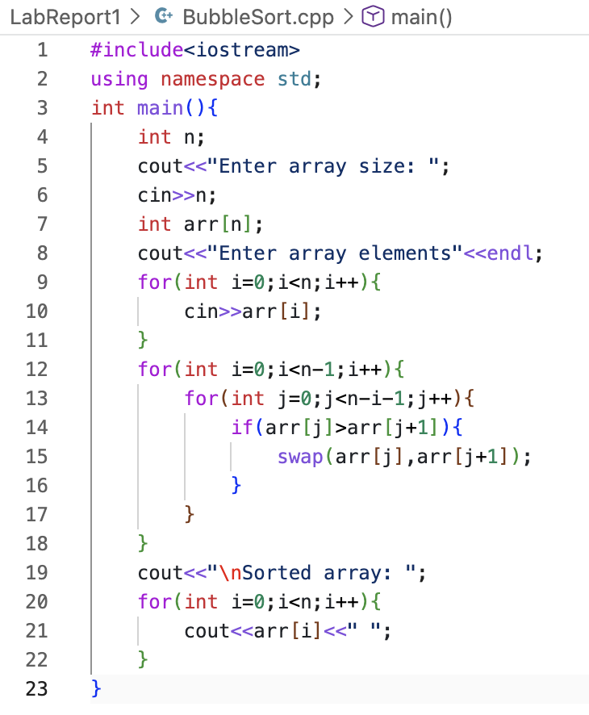
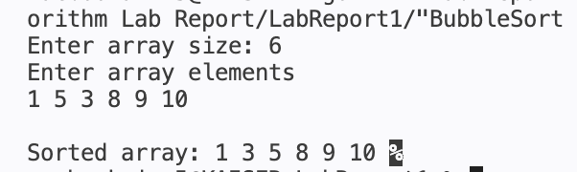
Conclusion
The program has been successfully implemented using the Bubble Sort algorithm. The input elements were compared and swapped repeatedly until they were arranged in ascending order. Step by step, the larger elements moved to their correct positions at the end of the array. Finally, the sorted array was obtained correctly. It can be concluded that Bubble Sort is easy to understand and implement, but it is not very efficient for large datasets.

Problem 3: Selection Sort (Ascending Order)

Objective
- To implement the Selection Sort algorithm using C++.
- To take user input for array size and elements.
- To sort the given array in ascending order.
- To understand how the minimum element is selected in each iteration.
- To observe how elements are placed in their correct positions step by step.

Source Code
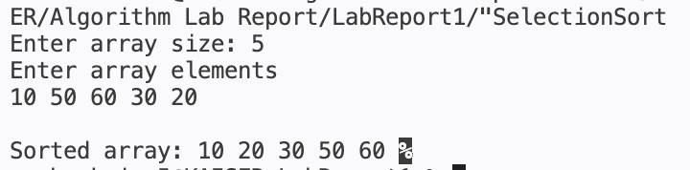
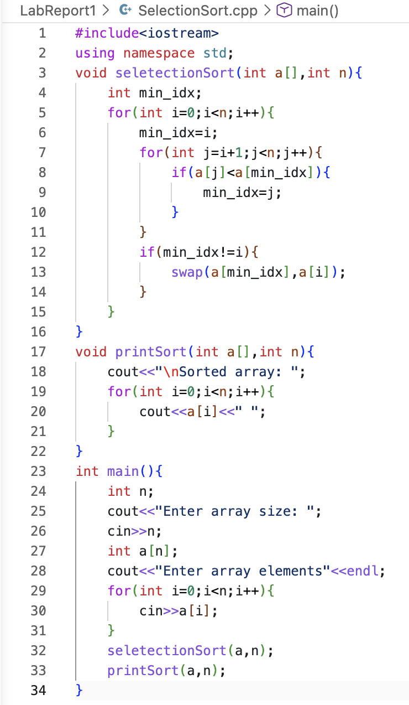
Input and Output

Conclusion
The program was successfully implemented using the Selection Sort algorithm. The input elements were processed by repeatedly selecting the smallest element from the unsorted portion of the array and placing it in its correct position. This process continued step by step until the entire array was sorted in ascending order. Finally, the sorted array was obtained correctly. It can be concluded that Selection Sort is simple and easy to understand, but it is not very efficient for large datasets.

